This user guide is intended to help you understand how to complete the Unified Referral Process when the intake process begins at a DBHDD hospital.
Contents
Completing the Needs Supportive Housing Survey (Regional staff guidance starts here) 2
First Step: Start a New Survey 2
Section 1: Demographics/Provider Information 3
Section 3: Current Living Situation 4
Section 5: Supported Housing Resources and Services 5
Submitting Completed Sections 1-5: 5
Completing a Referral (Hospital social workers guidance starts here) 9
How to Retrieve/Find a Survey: 9
Submitting Documents 12
Initial Housing Referral Process Form 13
Saving Your Progress 13
Stage 1: Additional Information 14
Stage 2: Initial Housing Referral Process Form 16

Completing the Needs Supportive Housing Survey (Regional staff guidance starts here)
Note: Regional staff is responsible for completing the intake (sections 1 to 5) of the NSH.

First Step: Start a New Survey
- Login to the NSH application.
- Click on the “Search” button on the landing page.
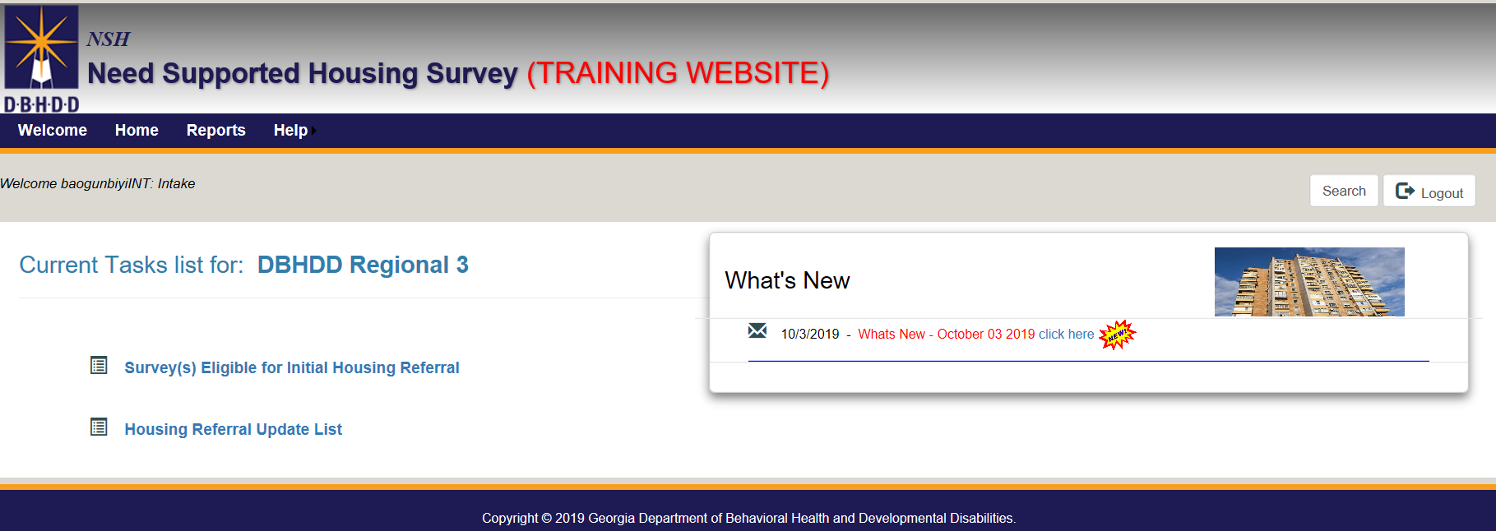
- Click on “New Survey” button to begin a new survey.
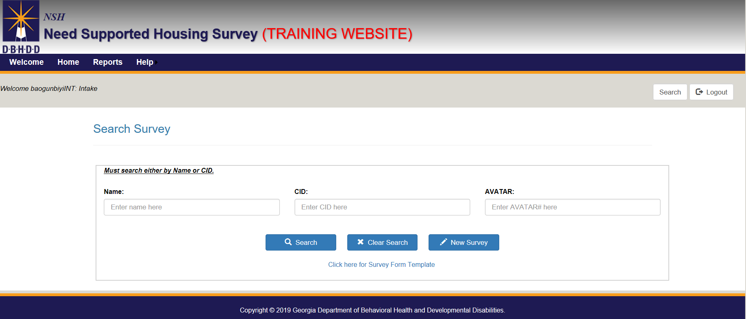

Section 1: Demographics/Provider Information
- Agency Name: Choose a provider agency from the dropdown that would provide services for the individual in the community.
- Service Type: Select “Community Based Inpatient (Psych)” from the dropdown.
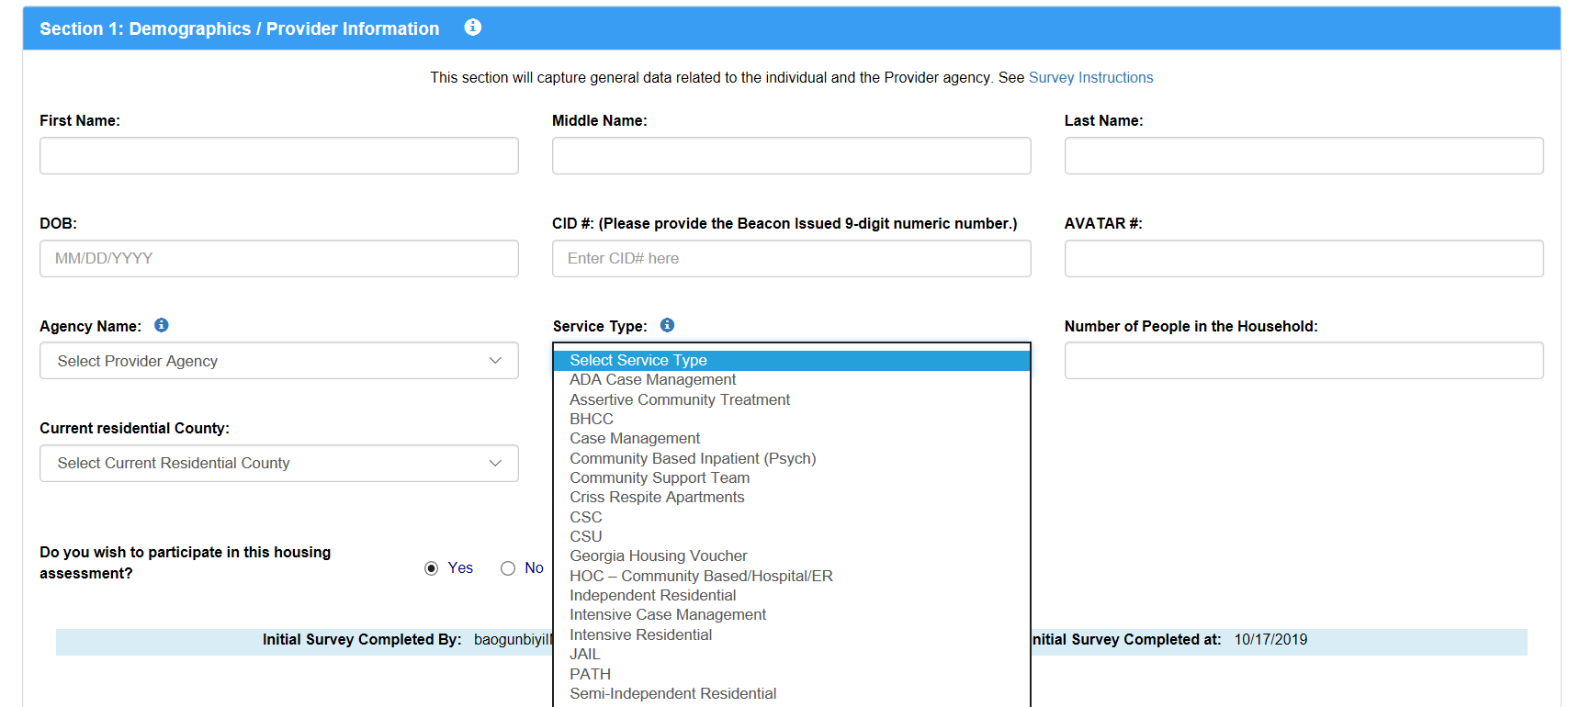
- Click “Continue” button upon completion of Section 1.
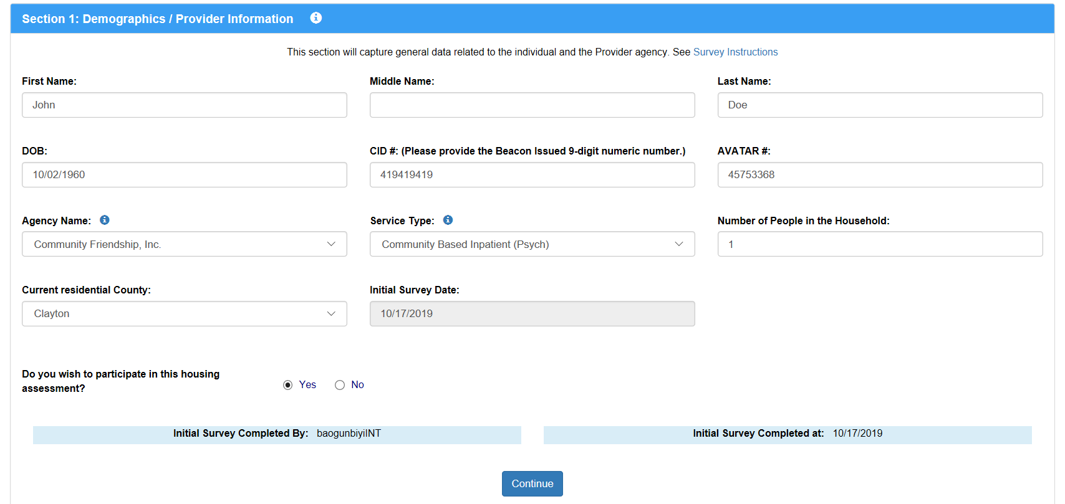

- Proceed to complete Sections 2 through Section 5.
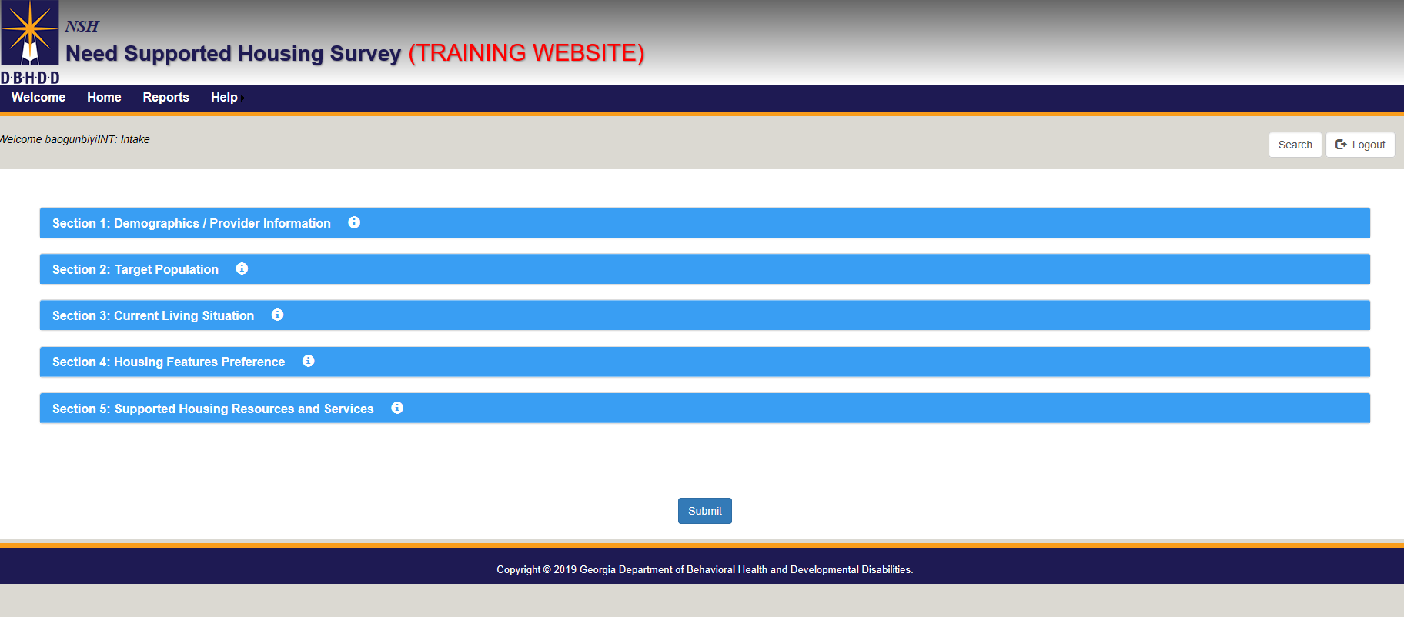

Section 3: Current Living Situation

- Select the “DBHDD Hospital” option for Question 1: “Where does this individual live now.”
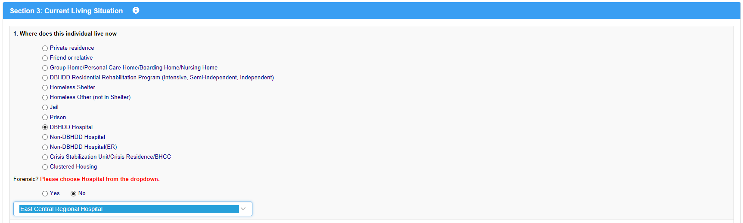

Section 5: Supported Housing Resources and Services

- For Question 6: “Do You Need Supported Housing,” An option must be selected from the dropdown menu.
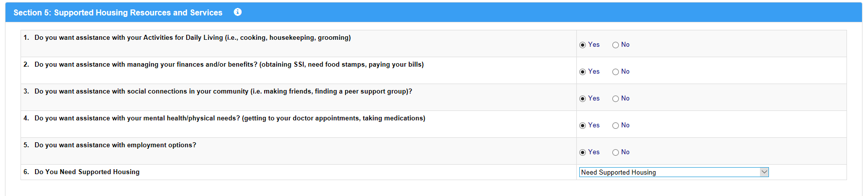

Submitting Completed Sections 1-5:
- After completing sections 1 through 5 of the survey, click “Submit”
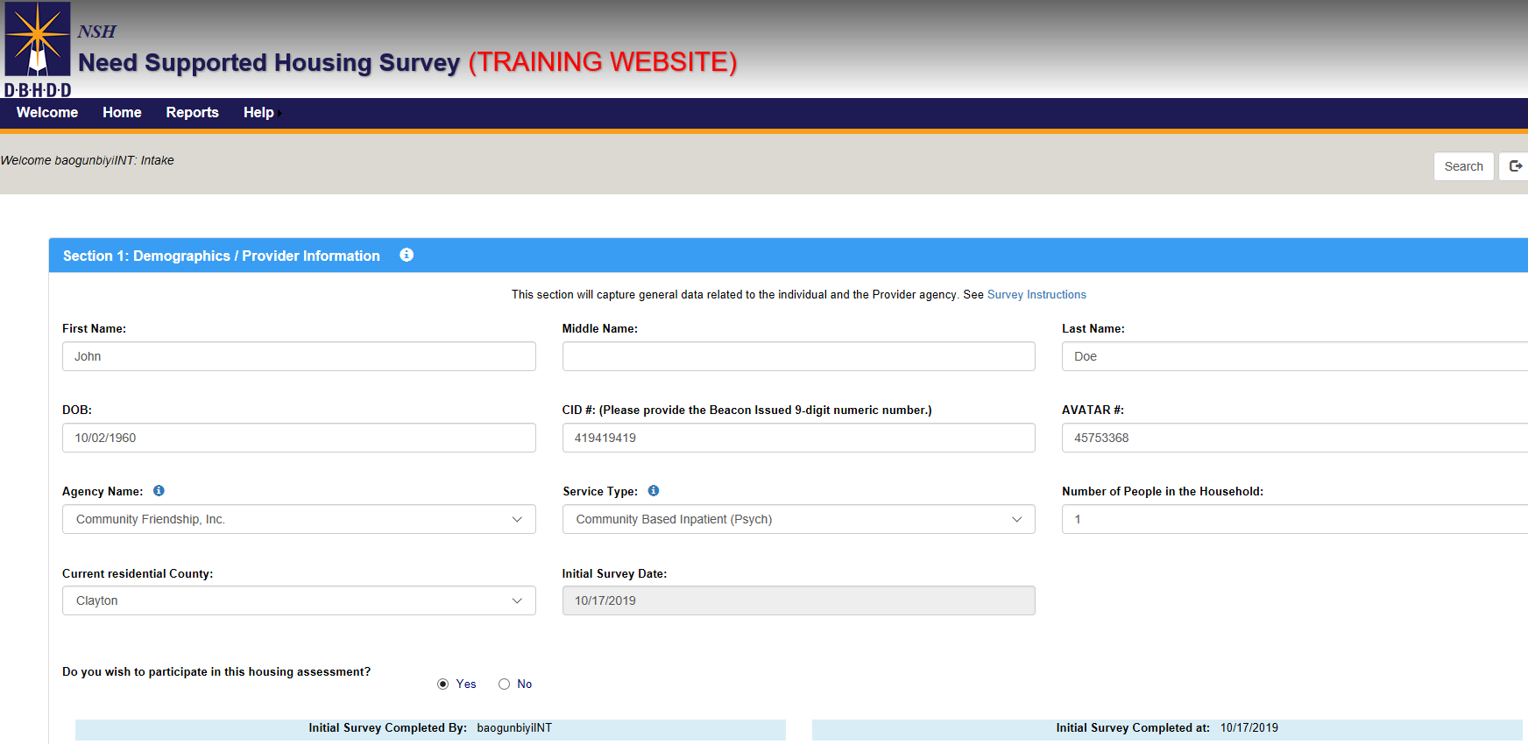
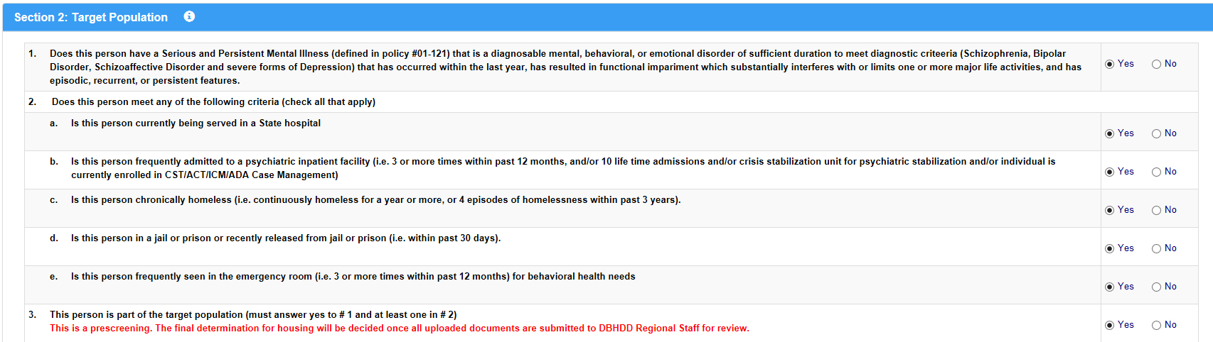
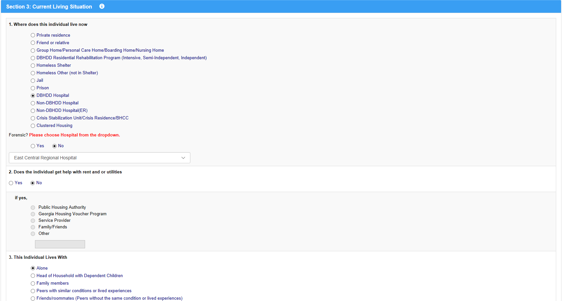

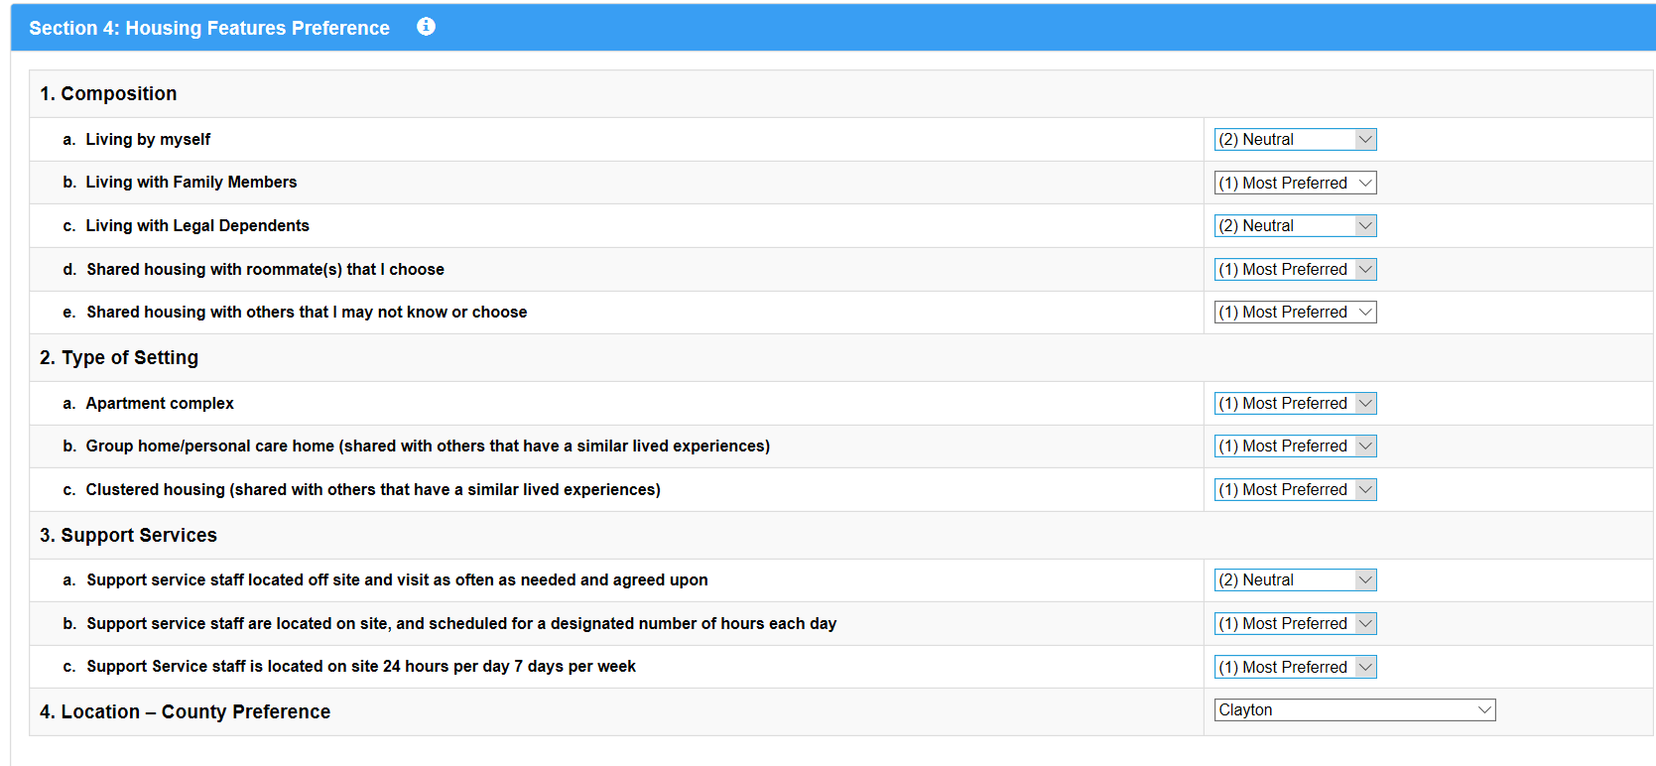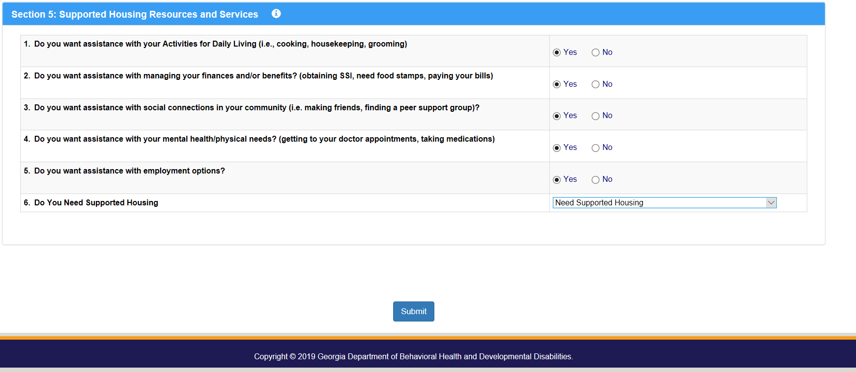

- After clicking on the “Submit” button, a page displaying the message, “Survey was successfully submitted,” should appear.
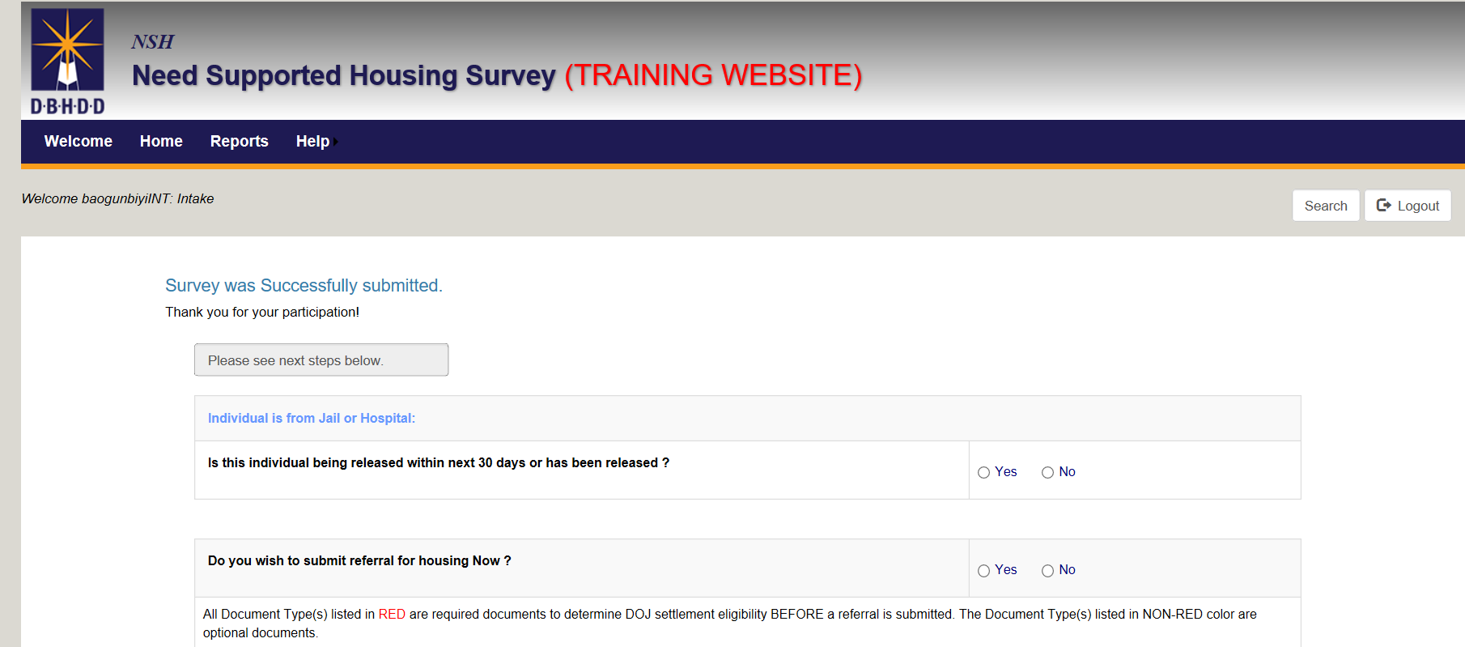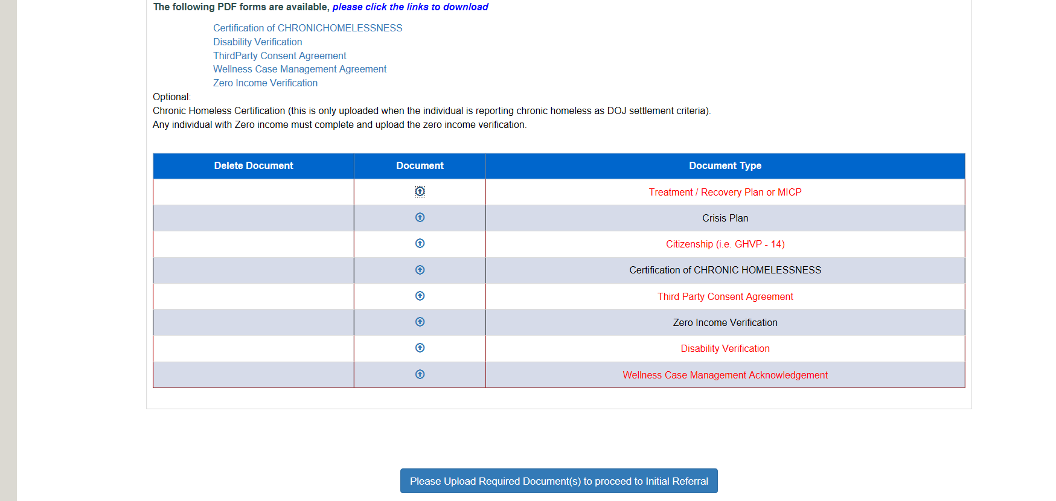

Completing a Referral (Hospital social workers guidance starts here)
Note: Hospital staff is responsible for completing the unified referral (UR). Hospital social workers are only able to make a referral after the regional staff has submitted the NSH survey.
After a survey is complete, the next step is completing a referral for the individual.

How to Retrieve/Find a Survey:
In order to retrieve a survey to complete a referral, the hospital staff person must:
- Log in to the NSH application.
- Click on the “Search” button on the landing page.
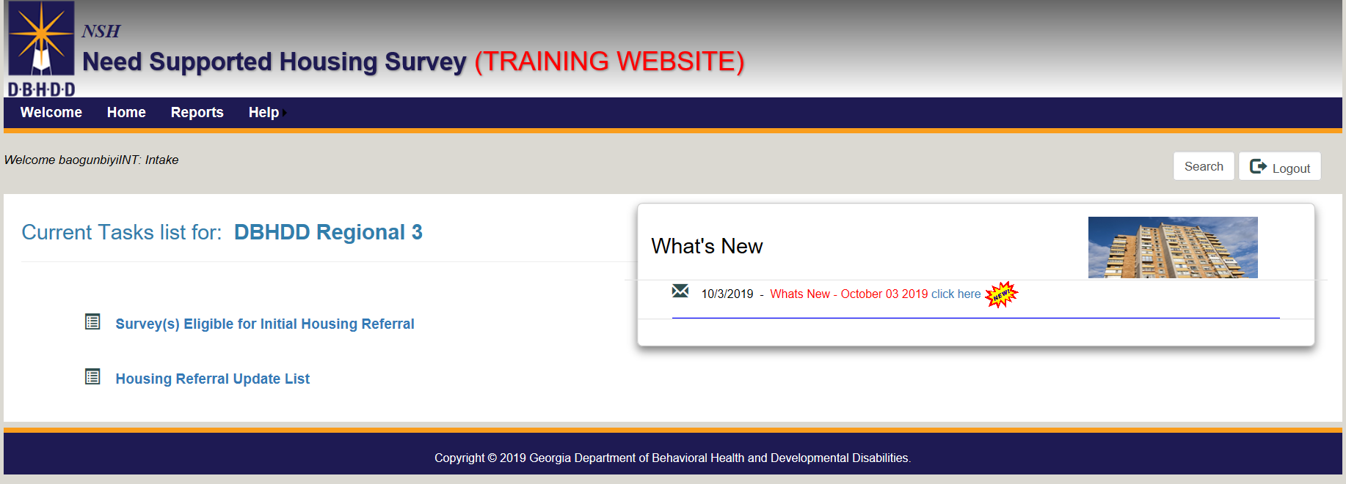

- Search the name of the individual in the “Name” field.
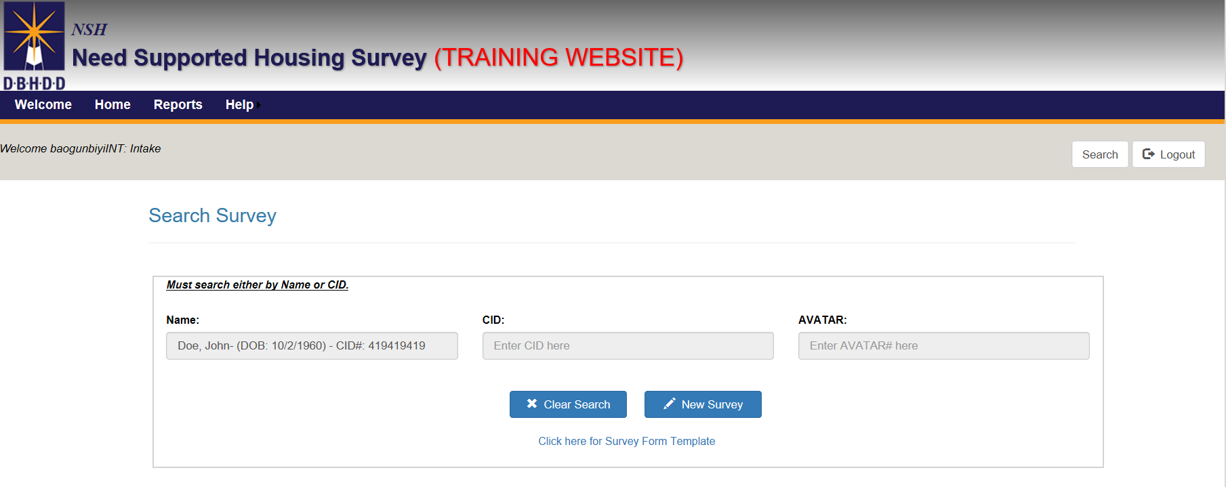
- Click on the icon to open a completed survey.
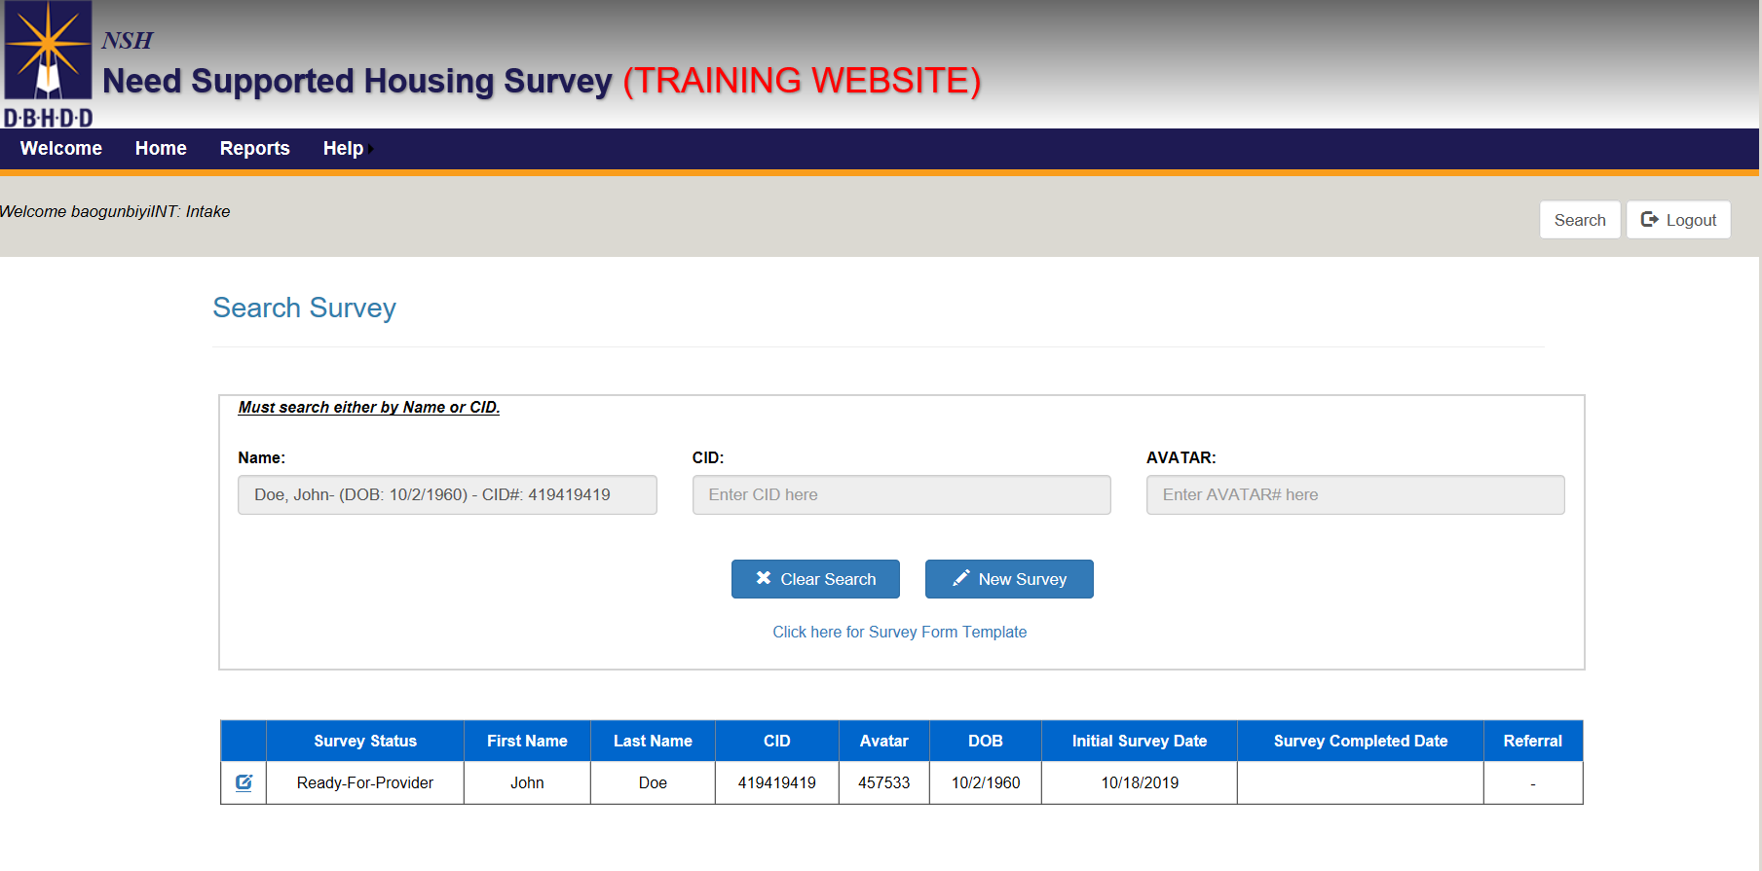

- The completed survey should appear and indicate that its status is “Ready-for-Provider” and it is “Active”
- Click on the “Submit” button to proceed to the “Initial Referral Form”.
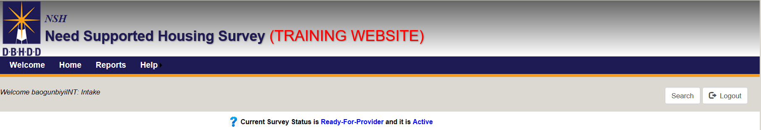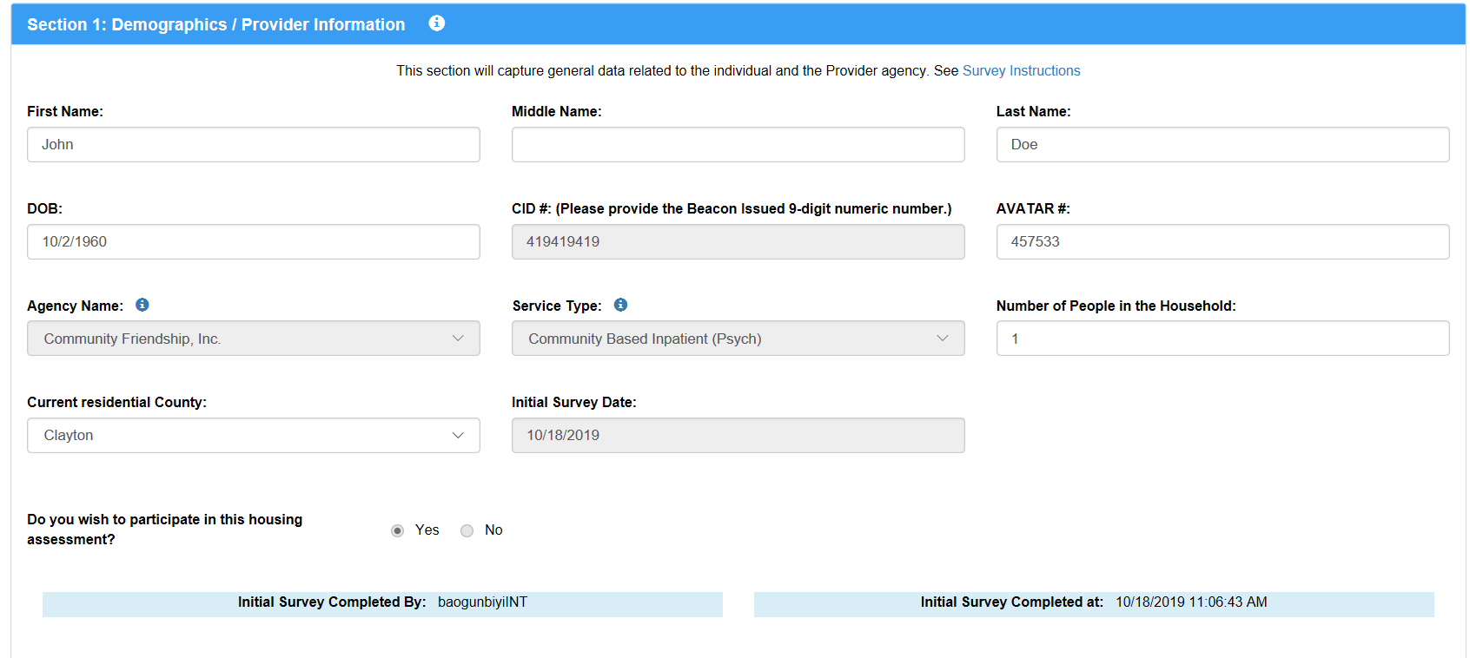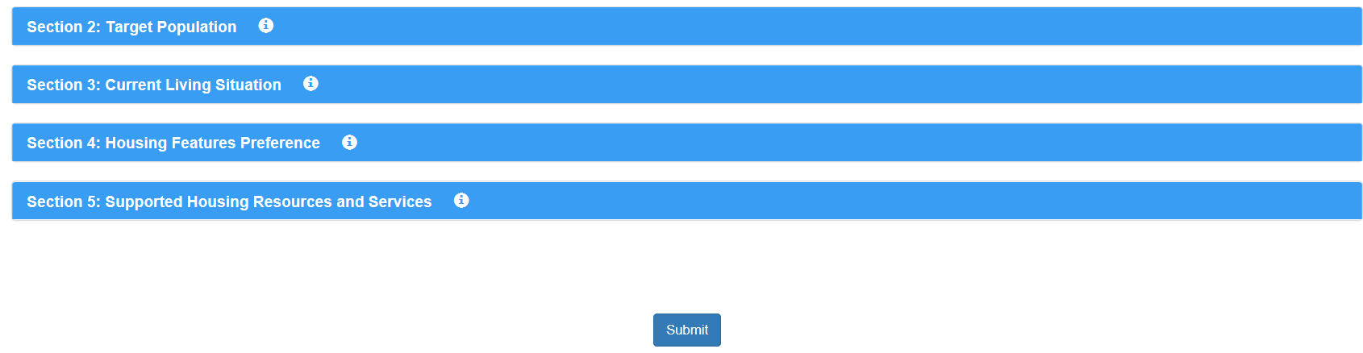

- The “Survey was Successfully submitted” page (displayed below) should appear.
- Provide answers to the two questions “ Is this individual being released within next 30 days or has been released?” and “ Do you wish to submit referral for housing now?”

Submitting Documents

- Upload all the necessary documents and click “Continue”.
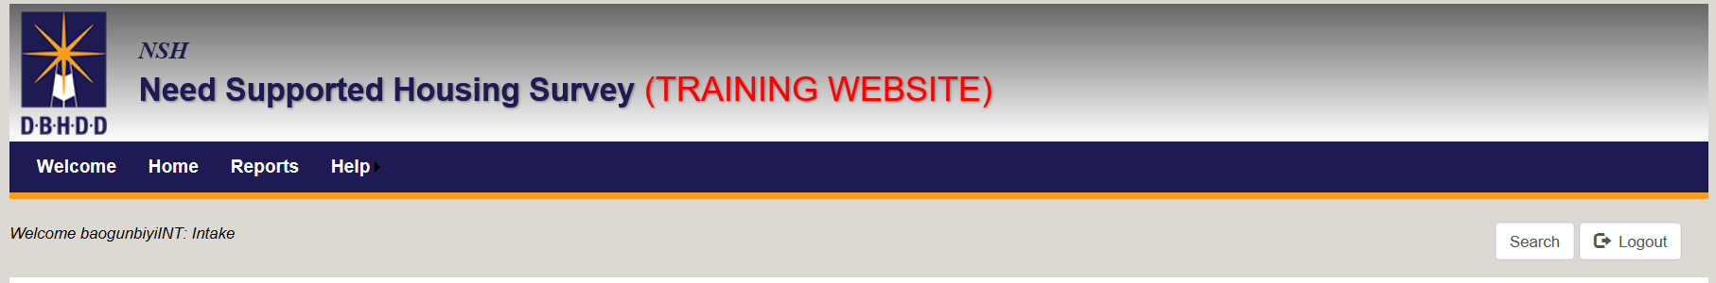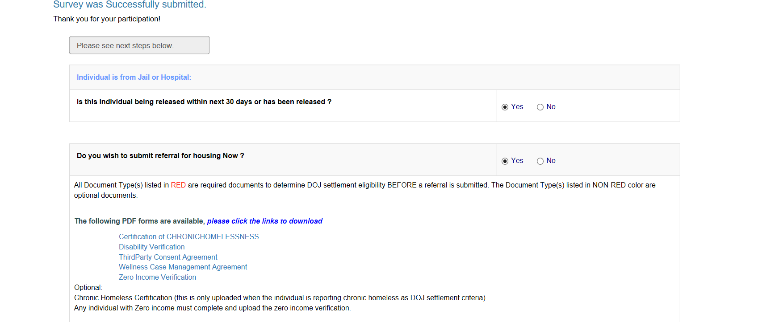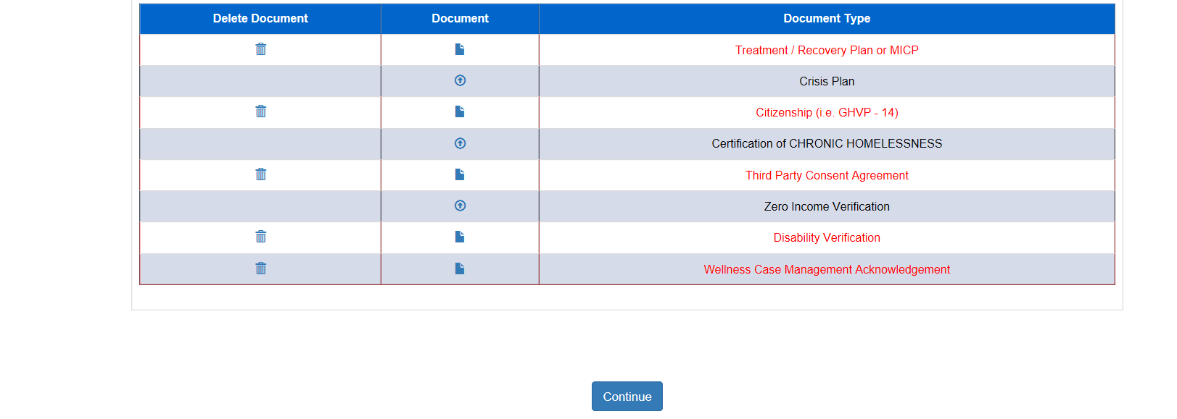

Initial Housing Referral Process Form
The Initial Housing Referral Process form has been split into two stages.
The first stage of the referral form now contains the ten (10) text boxes describing the current functioning of an individual in the additional information section of the referral form. This provides an opportunity to fill out the text boxes and save progress.

Caution: The application will time out after 15 minutes of inactivity.

- Users must complete the 10 additional information text boxes in Stage 1 and click on “Submit” before moving to the Stage 2 of the referral form.
- Each text box has a description guide for the information that needs to be entered.
- A maximum of 500 characters can be entered in each text box.

Saving Your Progress

- Users can use the “Save Progress” button if Section 1 is not completed. Information entered would be saved and users can return to complete the section later.
- When users save their progress, the following display should appear:
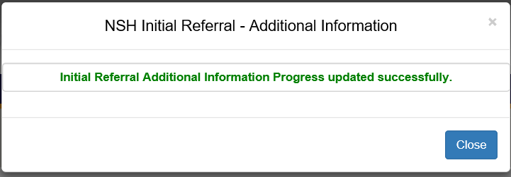

Stage 1: Additional Information
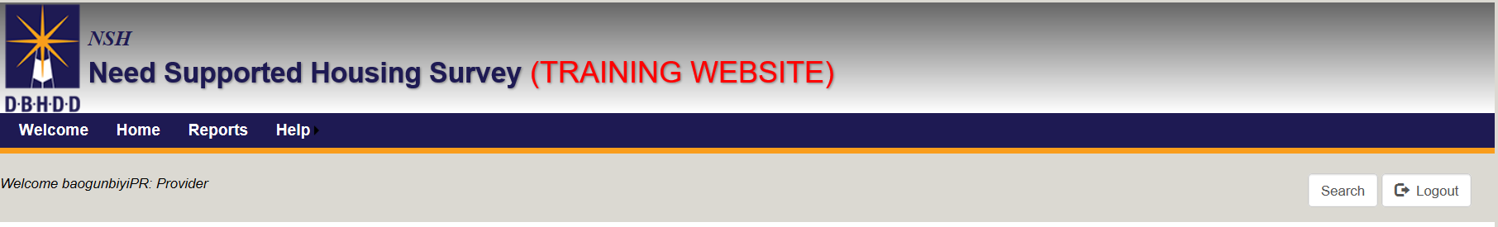
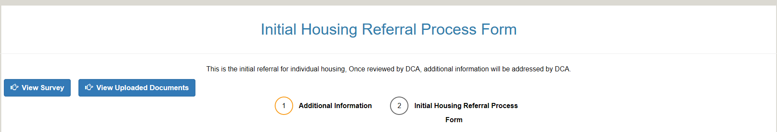
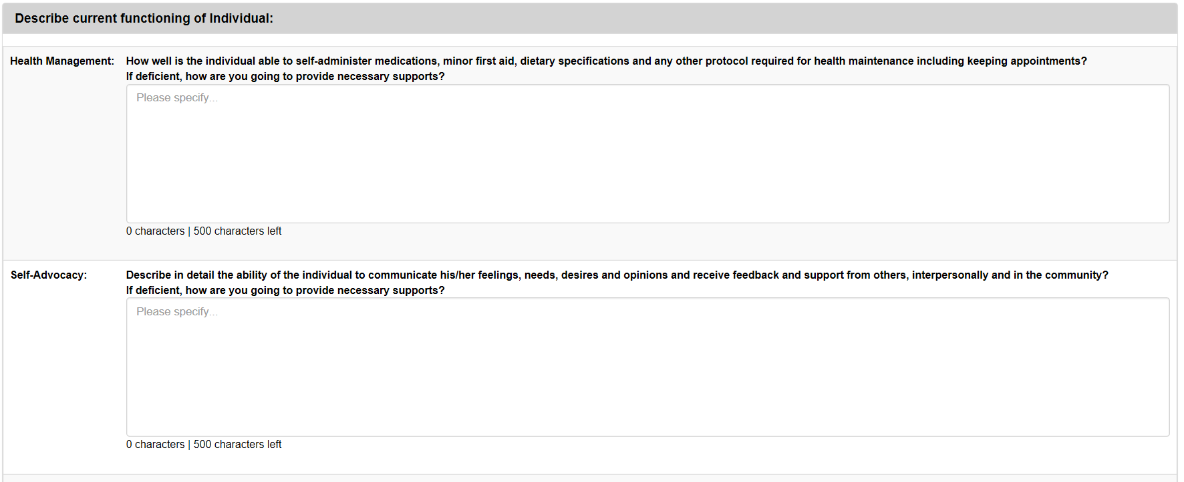
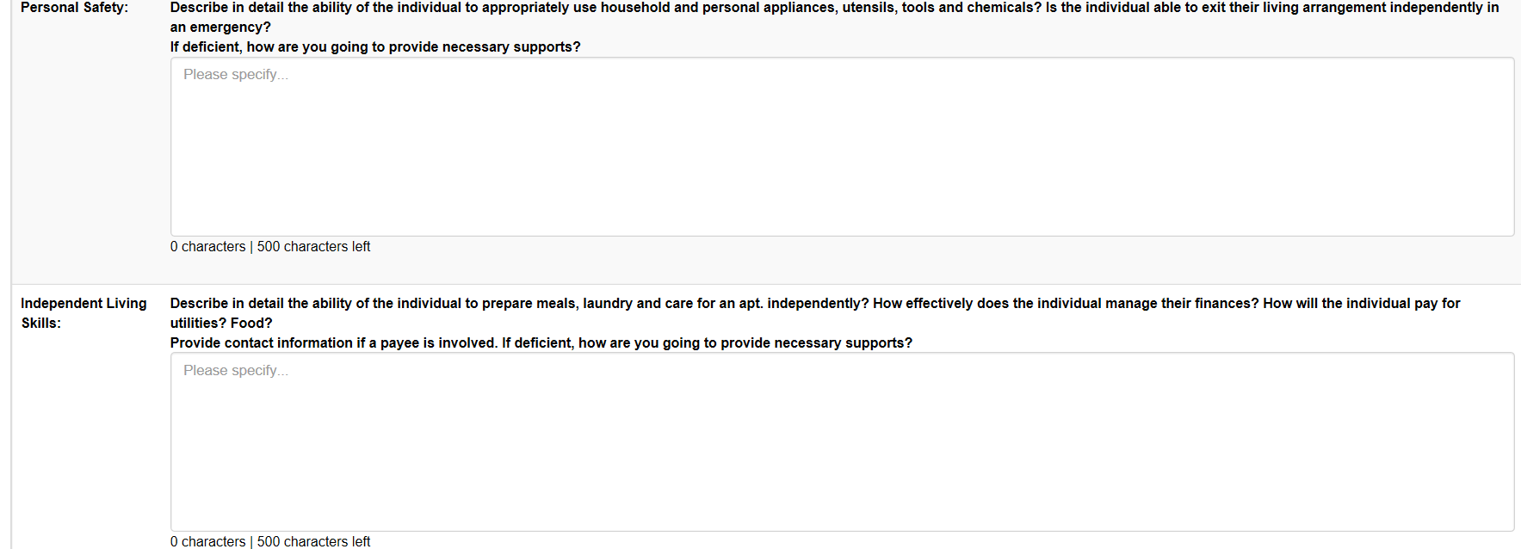

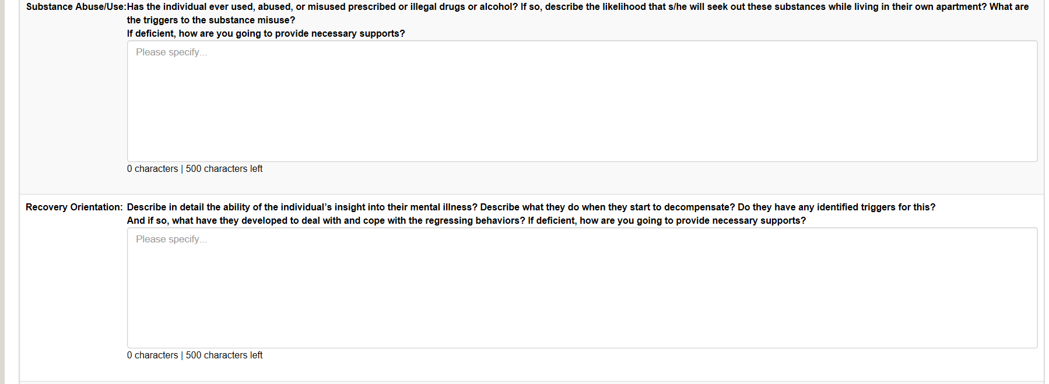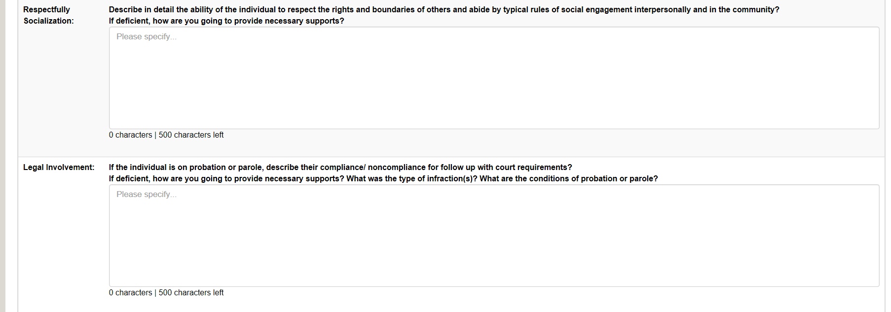
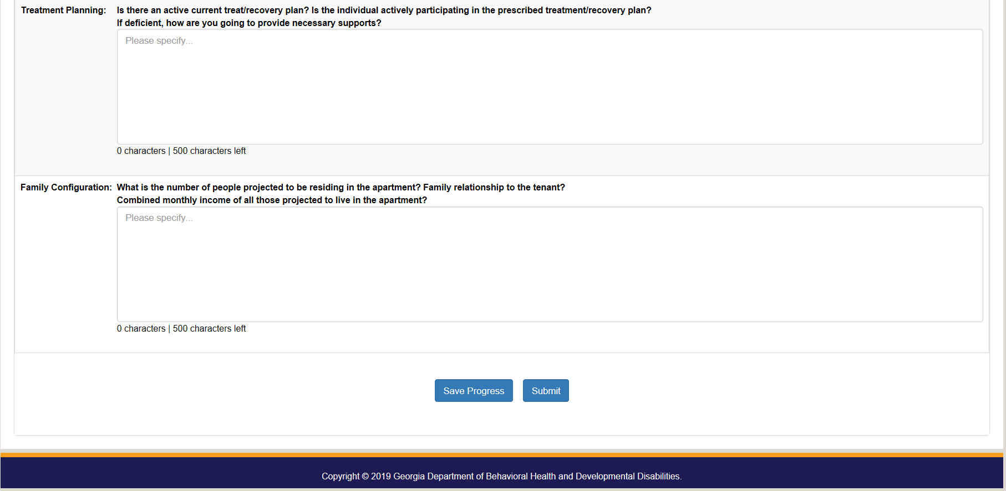
Please see above for notes on this stage and saving progress on the application.
- Click “Submit” when complete to proceed to Stage 2.

Stage 2: Initial Housing Referral Process Form

- When users complete all the text boxes and click on “Submit” to proceed to Stage 2: “Initial Housing Referral Process Form,” this message should appear:
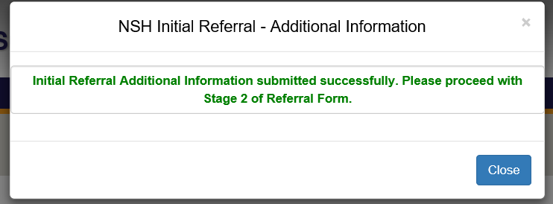
- Users should complete the remainder of the Initial Housing Referral Process Form in one sitting. Stage 2 does not have a save progress functionality.

- To proceed to Stage 2 of the referral, click on the yellow circle “2” labelled “Initial Housing Referral Process Form.”
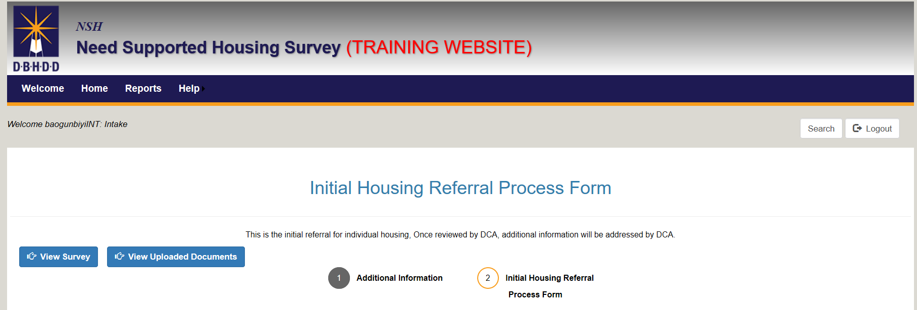
- Complete the entire Stage 2 (displayed below), then click the “Submit Initial Referral” button.
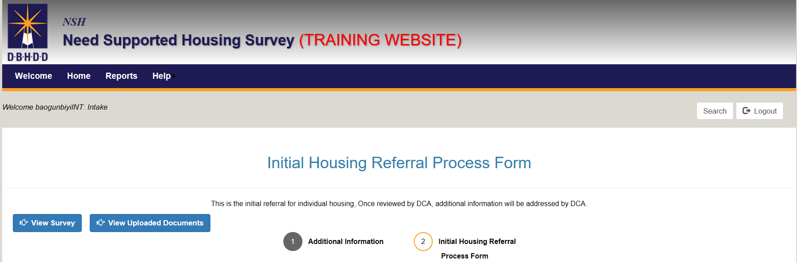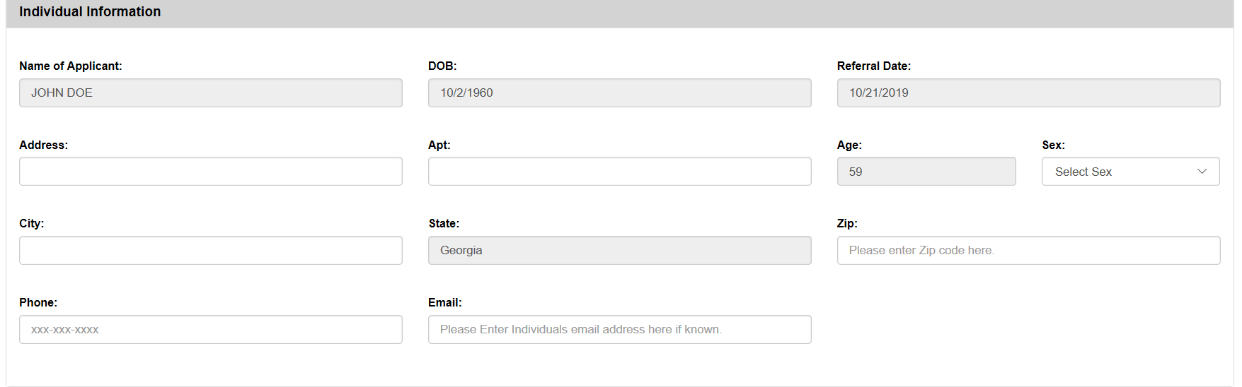
When this page is successfully submitted, that completes the referral application!

